ASSIGNMENT 2

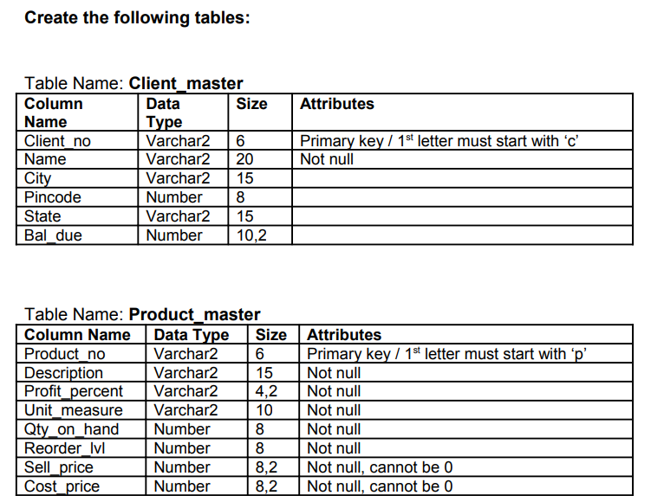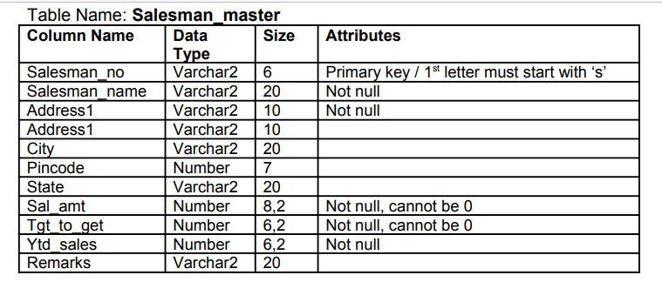

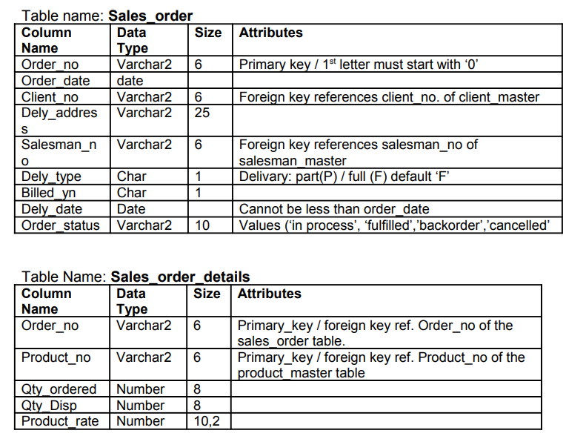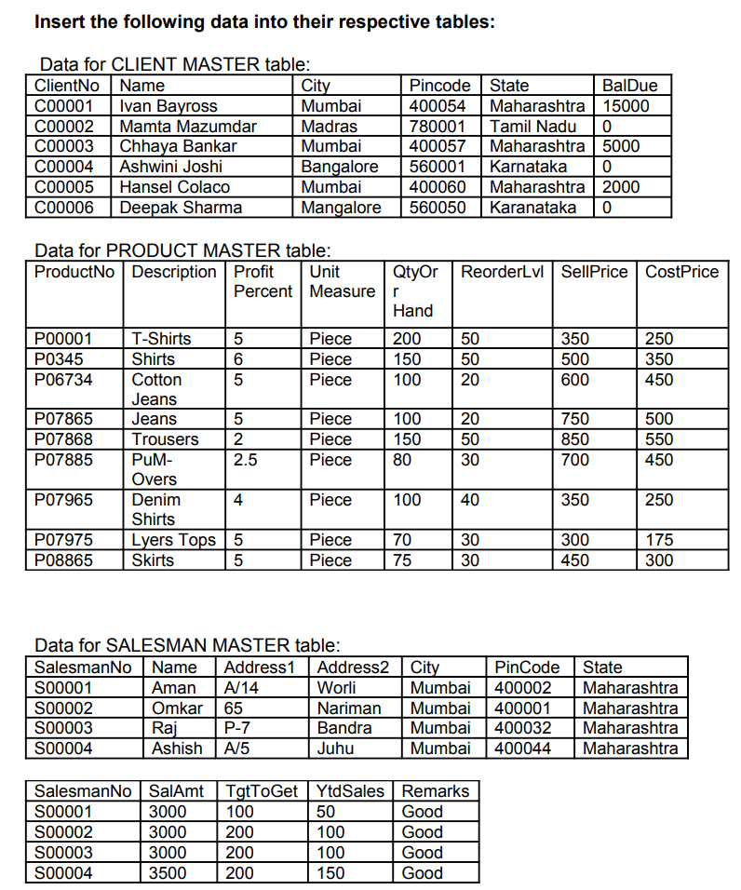

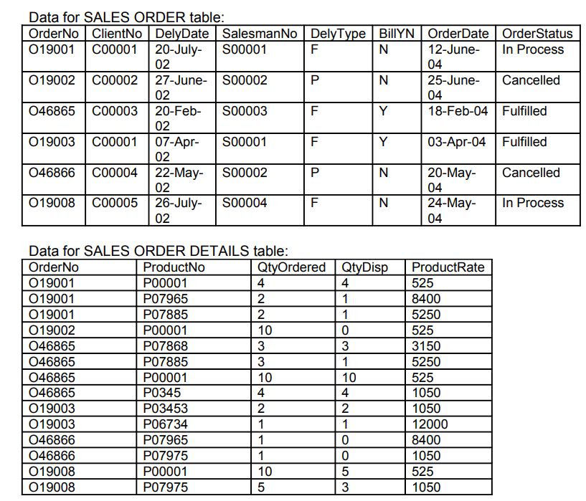

create table Client_master (

Client_no varchar2(6) **Check (Client_no LIKE 'C%') PRIMARY KEY,**

Name Varchar2(20) NOT NULL,

City Varchar2(15),

Pincode Number(8),

State Varchar2(15),

Bal_due Number(10,2));

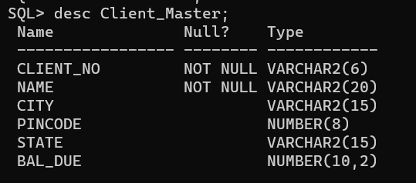

INSERT ALL

INTO Client_master (Client_no,Name,City,Pincode,State,Bal_due) VALUES ('C00001','Iavn Bayross','Mumbai',400054,'Maharashtra',15000)

INTO Client_master (Client_no,Name,City,Pincode,State,Bal_due) VALUES ('C00002','Mamta Mazumdar','Madras',780001,'Tamil Nadu',0)

INTO Client_master (Client_no,Name,City,Pincode,State,Bal_due) VALUES ('C00003','Chhaya Bankar','Mumbai',400057,'Maharashtra',5000)

INTO Client_master (Client_no,Name,City,Pincode,State,Bal_due) VALUES ('C00004','Ashwini Joshi','Bangalore',560001,'Karnataka',0)

INTO Client_master (Client_no,Name,City,Pincode,State,Bal_due) VALUES ('C00005','Hansel Colaco','Mumbai',400060,'Maharashtra',2000)

INTO Client_master (Client_no,Name,City,Pincode,State,Bal_due) VALUES ('C00006','Deepak Sharma','Mangalore',560050,'Karnataka',0)

SELECT * FROM DUAL;

**Instead of SELECT * FROM DUAL; you may write SELECT 1 FROM DUAL; also**

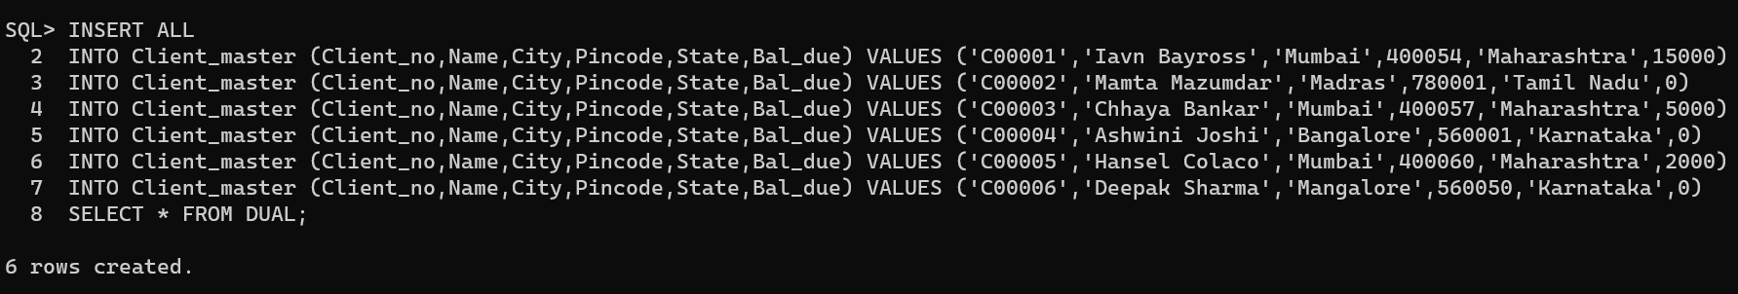

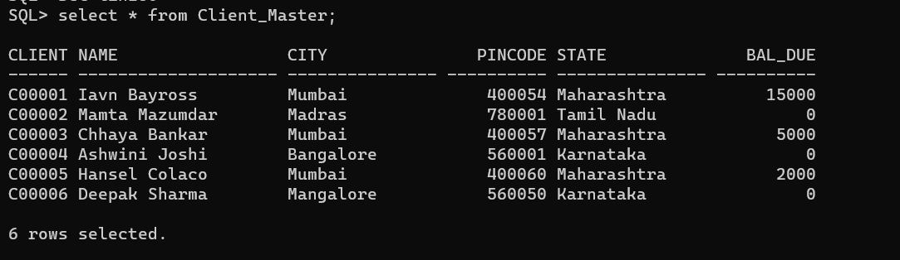

create table Product_master (

product_no Varchar2(6) Check (Product_no LIKE 'P%') PRIMARY KEY,

Description Varchar2(15) NOT NULL,

Profit_percent Number(4,2) NOT NULL,

Unit_measure Varchar2(10) NOT NULL,

Qty_on_hand Number(8) NOT NULL,

Reorder_lvl Number(8) NOT NULL,

Sell_price Number(8,2) **check(Sell_price < > 0) NOT NULL**,

Cost_price Number(8,2) check(Cost_price < > 0) NOT NULL);

INSERT ALL

INTO Product_master (product_no,Description,Profit_percent,Unit_measure,Qty_on_hand,Reorder_lvl,Sell_price,Cost_price) VALUES ('P00001','T-shirt',5,'Piece',200,50,350,250)

INTO Product_master (product_no,Description,Profit_percent,Unit_measure,Qty_on_hand,Reorder_lvl,Sell_price,Cost_price) VALUES ('P0345','Shirt',6,'Piece',150,50,500,350)

INTO Product_master (product_no,Description,Profit_percent,Unit_measure,Qty_on_hand,Reorder_lvl,Sell_price,Cost_price) VALUES ('P06734','Cotton Jeans',5,'Piece',100,20,600,450)

INTO Product_master (product_no,Description,Profit_percent,Unit_measure,Qty_on_hand,Reorder_lvl,Sell_price,Cost_price) VALUES ('P07865','Jeans',5,'Piece',100,20,750,500)

INTO Product_master (product_no,Description,Profit_percent,Unit_measure,Qty_on_hand,Reorder_lvl,Sell_price,Cost_price) VALUES ('P07868','Trousers',2,'Piece',150,50,850,550)

INTO Product_master (product_no,Description,Profit_percent,Unit_measure,Qty_on_hand,Reorder_lvl,Sell_price,Cost_price) VALUES ('P07885','PuM-Overs',2.5,'Piece',80,30,700,450)

INTO Product_master (product_no,Description,Profit_percent,Unit_measure,Qty_on_hand,Reorder_lvl,Sell_price,Cost_price) VALUES ('P07965','Denim Shirts',4,'Piece',100,40,350,250)

INTO Product_master (product_no,Description,Profit_percent,Unit_measure,Qty_on_hand,Reorder_lvl,Sell_price,Cost_price) VALUES ('P07975','Lyers Tops',5,'Piece',70,30,300,175)

INTO Product_master (product_no,Description,Profit_percent,Unit_measure,Qty_on_hand,Reorder_lvl,Sell_price,Cost_price) VALUES ('P08865','Skirts',5,'Piece',75,30,450,300)

SELECT * FROM DUAL;

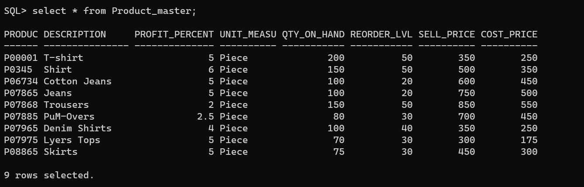

create table Salesman_master (

Salesman_no Varchar2(6) check(Salesman_no LIKE 'S%') PRIMARY KEY,

Salesman_name Varchar2(20) NOT NULL,

Address1 Varchar2(10) NOT NULL,

Address2 Varchar2(10),

City Varchar2(20),

Pincode Number(7),

State Varchar2(20),

Sal_amt Number(8,2) check(Sal_amt <> 0) NOT NULL,

Tgt_to_get Number(6,2) check(Tgt_to_get <> 0) NOT NULL,

Ytd_sales Number(6,2) NOT NULL,

Remarks Varchar2(20));

INSERT ALL

INTO Salesman_master (Salesman_no,Salesman_name,Address1,Address2,City,Pincode,State,Sal_amt,Tgt_to_get,Ytd_sales,Remarks) VALUES ('S00001','Aman','A/14','Worli','Mumbai',400002,'Maharashtra',3000,100,50,'Good')

INTO Salesman_master (Salesman_no,Salesman_name,Address1,Address2,City,Pincode,State,Sal_amt,Tgt_to_get,Ytd_sales,Remarks) VALUES ('S00002','Omkar','65','Nariman','Mumbai',400001,'Maharashtra',3000,200,100,'Good')

INTO Salesman_master (Salesman_no,Salesman_name,Address1,Address2,City,Pincode,State,Sal_amt,Tgt_to_get,Ytd_sales,Remarks) VALUES ('S00003','Raj','P-7','Bandra','Mumbai',400032,'Maharashtra',3000,200,100,'Good')

INTO Salesman_master (Salesman_no,Salesman_name,Address1,Address2,City,Pincode,State,Sal_amt,Tgt_to_get,Ytd_sales,Remarks) VALUES ('S00004','Asish','A/5','Juhu','Mumbai',400044,'Maharashtra',3500,200,150,'Good')

SELECT * FROM DUAL;

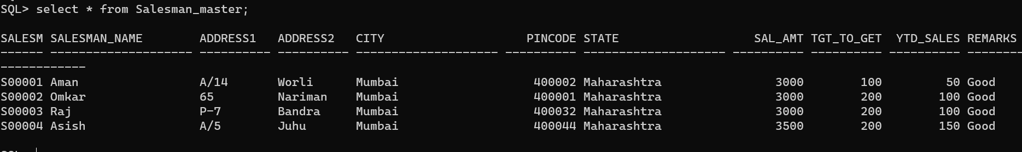

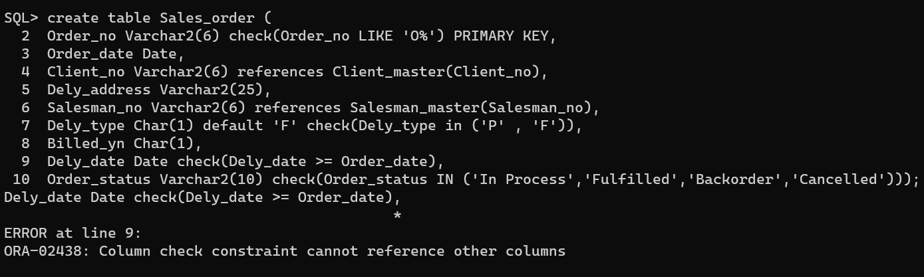



create table Sales_order (

Order_no Varchar2(6) check(Order_no LIKE 'O%') PRIMARY KEY,

Order_date Date,

Client_no Varchar2(6) references Client_master(Client_no),

Dely_address Varchar2(25),

Salesman_no Varchar2(6) references Salesman_master(Salesman_no),

Dely_type Char(1) default 'F' check(Dely_type in ('P' , 'F')),

Billed_yn Char(1),

Dely_date Date,

constraint ck_date_correct check(Dely_date >= Order_date),

//ck_date_correct can be any variable

Order_status Varchar2(10) check(Order_status IN ('In Process','Fulfilled','Backorder','Cancelled')));

INSERT ALL

INTO Sales_order (Order_no,Order_date,Client_no,Dely_address,Salesman_no,Dely_type,Billed_yn,Dely_date,Order_status) VALUES ('O19001','12-JUN-2004','C00001',NULL,'S00001','F','N','20-JUL-2004','In Process')

INTO Sales_order (Order_no,Order_date,Client_no,Dely_address,Salesman_no,Dely_type,Billed_yn,Dely_date,Order_status) VALUES ('O19002','5-JUN-2004','C00002',NULL,'S00002','P','N','27-JUN-2004','Cancelled')

INTO Sales_order (Order_no,Order_date,Client_no,Dely_address,Salesman_no,Dely_type,Billed_yn,Dely_date,Order_status) VALUES ('O46865','18-FEB-2004','C00003',NULL,'S00003','F','Y','18-FEB-2004','Fulfilled')

INTO Sales_order (Order_no,Order_date,Client_no,Dely_address,Salesman_no,Dely_type,Billed_yn,Dely_date,Order_status) VALUES ('O19003','03-APR-2004','C00001',NULL,'S00001','F','Y','07-APR-2004','Fulfilled')

INTO Sales_order (Order_no,Order_date,Client_no,Dely_address,Salesman_no,Dely_type,Billed_yn,Dely_date,Order_status) VALUES ('O46866','20-MAY-2004','C00004',NULL,'S00002','P','N','22-MAY-2004','Cancelled')

INTO Sales_order (Order_no,Order_date,Client_no,Dely_address,Salesman_no,Dely_type,Billed_yn,Dely_date,Order_status) VALUES ('O19008','24-MAY-2004','C00005',NULL,'S00004','F','N','26-JUL-2004','In Process')

SELECT * FROM DUAL;

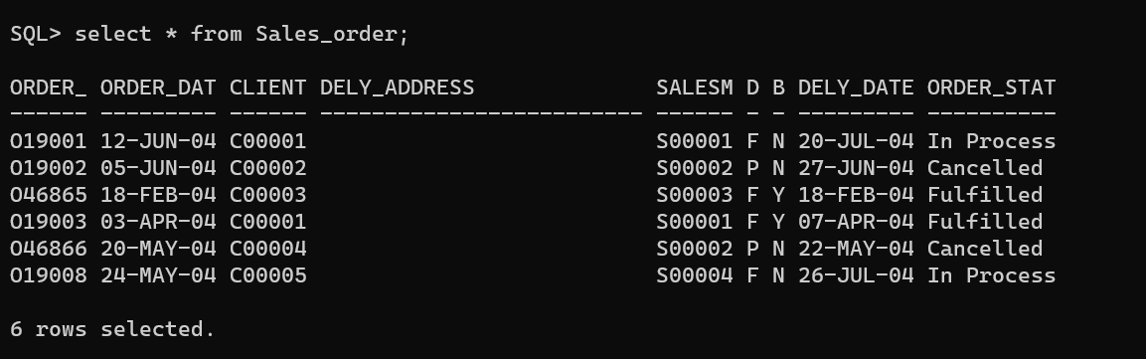

Both are ways to represents foreign key, in first case you do reference at the time of declaration only.

Note

CREATE TABLE SALES_ORDER_DETAILS(

**ORDER_NO VARCHAR2(6) REFERENCES SALES_ORDER(ORDER_NO),**

PRODUCT_NO VARCHAR(6),



QTY_ORDERED NUMBER(8),

QTY_DISP NUMBER(8),

PRODUCT_RATE NUMBER(10,2),

FOREIGN kEY(PRODUCT_NO) REFERENCES PRODUCT_MASTER(PRODUCT_NO),

PRIMARY KEY(ORDER_NO,PRODUCT_NO));

create table Sales_order_details (

Order_no Varchar2(6),

FOREIGN KEY (Order_no) REFERENCES Sales_order(Order_no),

Product_no varchar2(6),

FOREIGN KEY (Product_no) REFERENCES Product_master(PRODUCT_NO),

Oty_ordered Number(8),

Qty_disp Number(8),

Product_rate Number(10,2),

PRIMARY KEY(Order_no,Product_no));

INSERT ALL

INTO Sales_order_details (Order_no,Product_no,Oty_ordered,Qty_disp,Product_rate) VALUES ('O19001','P00001',4,4,525)

INTO Sales_order_details (Order_no,Product_no,Oty_ordered,Qty_disp,Product_rate) VALUES ('O19001','P07965',2,1,8400)

INTO Sales_order_details (Order_no,Product_no,Oty_ordered,Qty_disp,Product_rate) VALUES ('O19001','P07885',2,1,5250)

INTO Sales_order_details (Order_no,Product_no,Oty_ordered,Qty_disp,Product_rate) VALUES ('O19002','P00001',10,0,525)

INTO Sales_order_details (Order_no,Product_no,Oty_ordered,Qty_disp,Product_rate) VALUES ('O46865','P07868',3,3,3150)

INTO Sales_order_details (Order_no,Product_no,Oty_ordered,Qty_disp,Product_rate) VALUES ('O46865','P07885',3,1,5250)

INTO Sales_order_details (Order_no,Product_no,Oty_ordered,Qty_disp,Product_rate) VALUES ('O46865','P00001',10,10,525)

INTO Sales_order_details (Order_no,Product_no,Oty_ordered,Qty_disp,Product_rate) VALUES ('O46865','P0345',4,4,1050)

INTO Sales_order_details (Order_no,Product_no,Oty_ordered,Qty_disp,Product_rate) VALUES ('O19003','P0345',2,2,1050)

INTO Sales_order_details (Order_no,Product_no,Oty_ordered,Qty_disp,Product_rate) VALUES ('O19003','P06734',1,1,12000)

INTO Sales_order_details (Order_no,Product_no,Oty_ordered,Qty_disp,Product_rate) VALUES ('O46866','P07965',1,0,8400)

INTO Sales_order_details (Order_no,Product_no,Oty_ordered,Qty_disp,Product_rate) VALUES ('O46866','P07975',1,0,1050)

INTO Sales_order_details (Order_no,Product_no,Oty_ordered,Qty_disp,Product_rate) VALUES ('O19008','P00001',10,5,525)

INTO Sales_order_details (Order_no,Product_no,Oty_ordered,Qty_disp,Product_rate) VALUES ('O19008','P07975',5,3,1050)

SELECT * FROM DUAL;

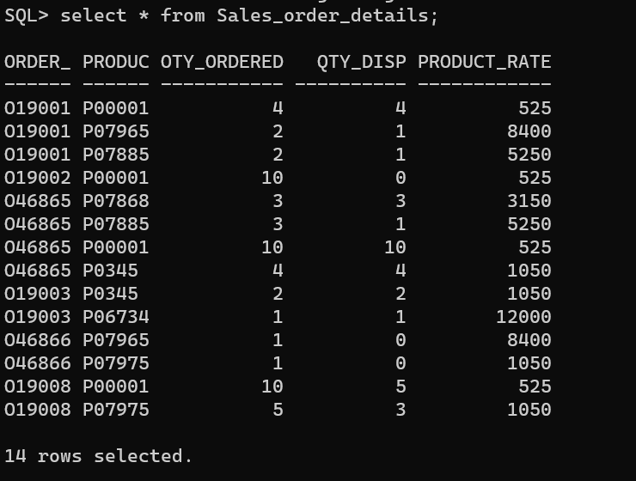

Write necessary SQL queries for the following:

1) Find the names of all clients having ‘a’ as the second letter in their names.

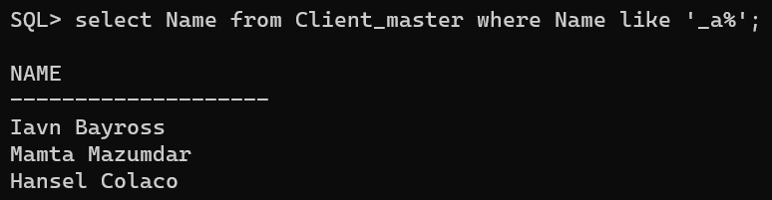

2) Find out the clients who stay in a city whose second letter is 'a'.

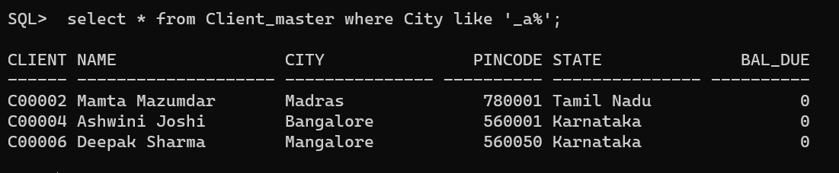

3) Find the list of all clients who stay in 'Bombay' or 'Delhi'

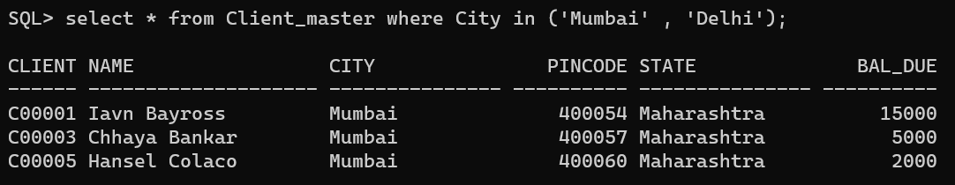

4) Print the list of clients whose bal_due is greater than value 10000.

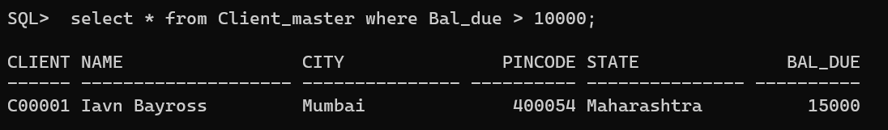

5) Print the information from sales_order table for orders placed in the month of January.

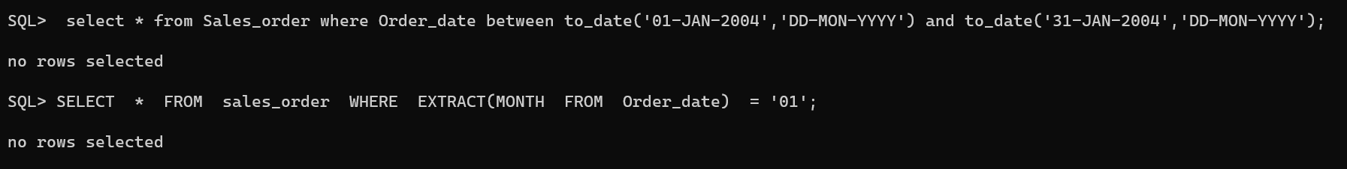

6) Display the order information for client_no 'C00001' and 'C00002'.

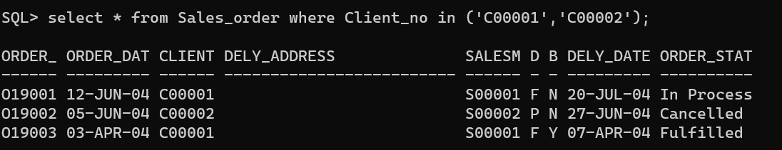

7) Find products whose selling price is greater than 2000 and less than or equal to 5000.



8) Find products whose selling price is more than 1500. Calculate a new selling price as original selling price * .15. Rename the new column in the above query as new_price.

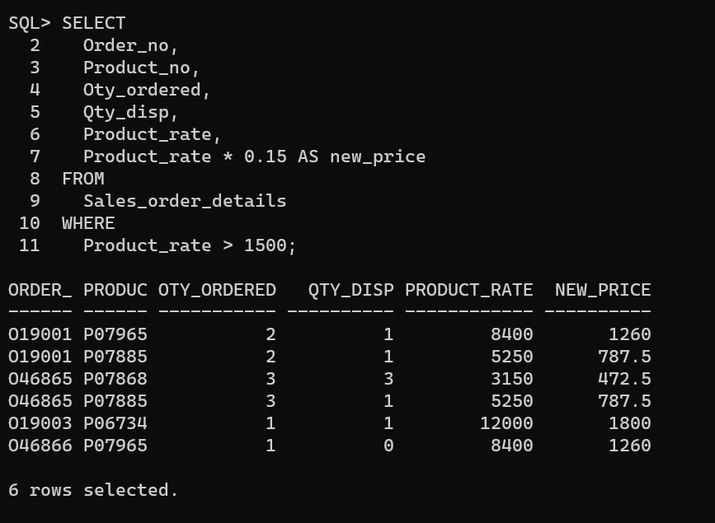

9) List the names, city and state of clients who are not in the state of 'Maharashtra'.

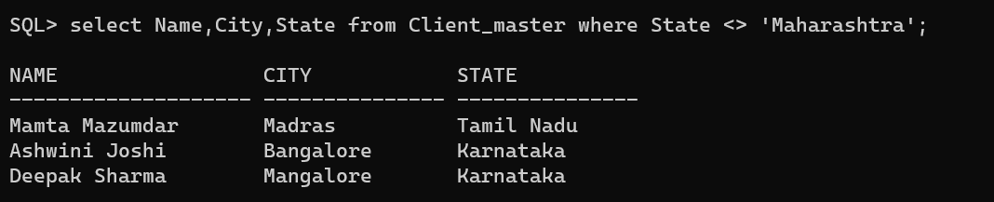

10) Count the total number of orders.

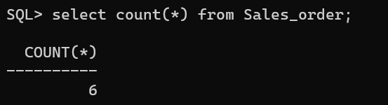

11) Calculate the average price of all the products.

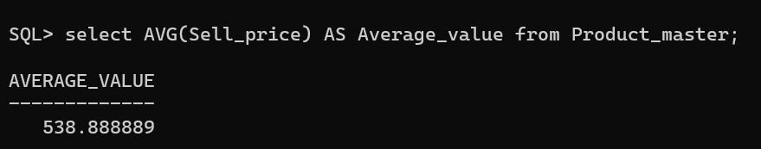

12) Determine the maximum and minimum product prices. Rename the output as max_price and min_price respectively.

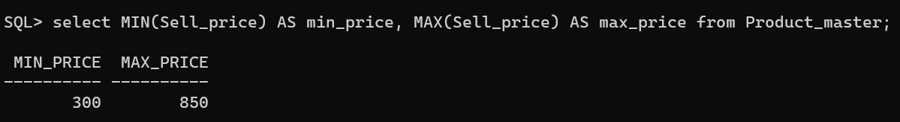

13) Count the number of products having price greater than or equal to 1500.

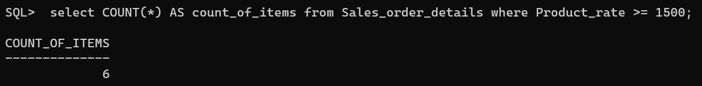

14) Find all the products whose qty_on_hand is less than reorder level.

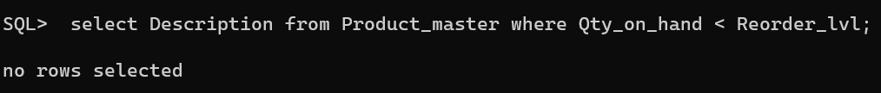

15)Display the order number and day on which clients placed their order

